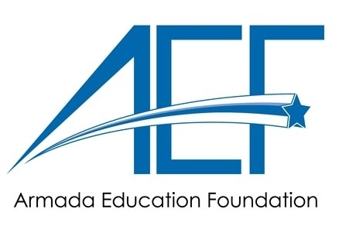
2024 Dick Enberg Memorial Golf Classic
August 4, 2024
SPONSORSHIP & GOLF REGISTRATION FORM

SPONSORSHIPS
Platinum Level $2,000 (Includes 4 Golfers & Large Banner) $
Double Eagle Level $1,500 (Includes 2 Golfers & Signage) $
Eagle Level $600 (Includes 1 of 12 Components) $___________
Birdie Level $300 (Sponsors of Continental Breakfast & Appetizers) $___________
Par Level $125 (Hole Sponsor) $___________

GOLF REGISTRATION
Names of Golfers: (If foursome is not finalized, write in TBA next to the number)
1._________________________________________________________________________
2._________________________________________________________________________
3._________________________________________________________________________
4._________________________________________________________________________

____ YES! Photos of me/my team taken at golf outing may be used in AEF communication materials and/or Facebook postings.

Company/Individual: _________________________________________________________
Team Captain/Contact: _______________________________________________________
Address: ___________________________________________________________________
Telephone: ________________________ Email: ___________________________________

AD COPY: ______ Same as last year ______ New ad copy

Ad copy must submitted by Friday, July 12, 2024. If copy is not received by deadline, a sign will be created using your Business name only. Send logo and artwork in PDF, or JPG format to Linda Lyons aef@armadaschools.org

Golf (includes dinner) - Golf Registration deadline – Monday, July 29, 2024
____ Golfers x $110 each ($100 each if paid by July 1st) = $___________
Dinner only
____ Dinners x $35 each = $___________

TOTAL Amount Due - (Checks payable to AEF): $___________

Mail this Sponsorship/Golf Registration form with your check to:
AEF, 74500 Burk Street, Armada, MI 48005.
Or, order online at:
www.armadaschools.org/our district/our-community/armada-education-foundation/

